Celebrating its 102nd Show

Horses  Included:  Horse Classes  Horse Declaration Form  Equestrian Waiver  Camping & Stabling Form | Saturday, August 31st  2019
For further information, please contact the Steward listed in the programme
or the Show Secretary:
Post: PO Box 159, Wondai 4606
Phone: 0427 685 171
Email: secretary@wondaishow.com.au
Camping on Friday & Saturday nights – free but unpowered sites only available

Check the show website (www.wondaishow.com.au) & Facebook page for up-to-date information on the 2019 Show.

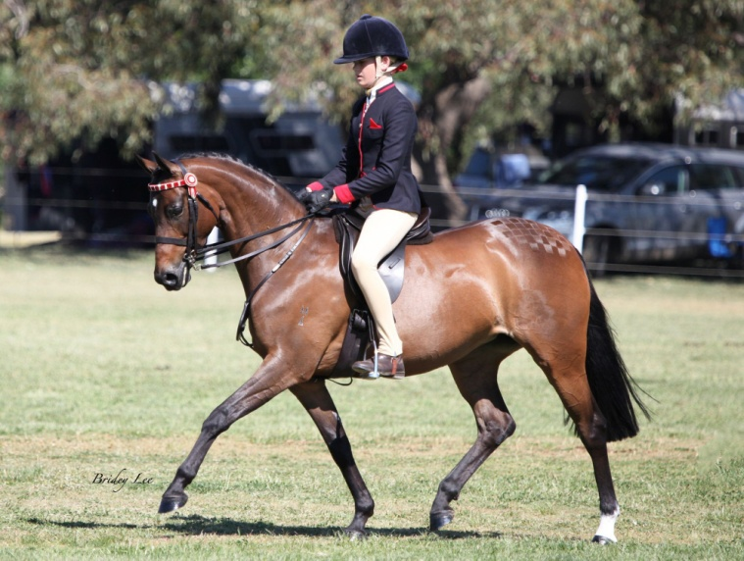
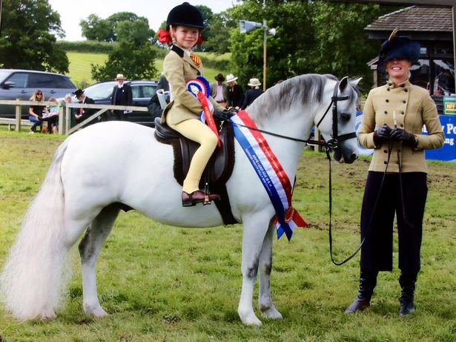

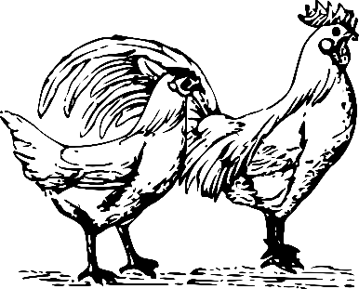
HORSE SECTION
CHIEF RING STEWARDS: LORRAINE RETSCHLAG Phone: 07 4169 0386 Mobile: 0448 642 178
Email: jlretschlag@bigpond.com
Rules and Regulations
- ALL EXHIBITORS MUST PAY THE GATE FEE ON ENTRY TO THE GROUNDS
- Stables MUST be pre booked (Form on website or contact the Chief Ring Steward)
- Hacks, Galloways & Ponies may be measured Saturday. (8.00 am to 8.30 am)
- The following DEFINITIONS and CONDITIONS shall apply:
PONY - Not exceeding 14 hands
GALLOWAY - Over 14 hands and not exceeding 15 hands
HACK - Over 15 hands
MAIDEN - A horse that has not won a first prize at an Agricultural Show excluding
local and district classes
- In the event of a dispute, the Rules of the Queensland Chamber of Agricultural Societies shall apply. A protest must be lodged at the secretary’s office in writing with a bond of $100.00 no later than 1 hour after the judging of the event in which the protest is to be made. The bond will be forfeited if the protest is turned down and refunded if the protest is upheld
- All competitors compete at their own risk
- All stallions and colts 1 year and over must be lead or ridden by a person 18 years or over
- Any prize not claimed during the show will be forfeited to the society
- Registration certificates & membership cards must be produced on request to the Judge in all classes
- The Judge shall withhold any prize ribbon when the exhibit is not of sufficient merit
- Exhibitors entered in the wrong classes may be transferred to the correct class at the discretion of the Chief Ring Steward
- The Society reserves the right to substitute special prizes which may be donated later for any advertised schedule prizes
- The Society reserves the right to amend the schedule at any time
- District events are restricted to the residents of the South Burnett Regional Council & Goomeri area
- The show hunter classes are supported by the Australian Hunter Horse Association (AHHA). Wondai show 2019 is an AHHA Show National Qualifier. You MUST be a financial member to compete in the AHHA classes
- Horses/ponies and handlers competing in the Restricted Ring may not compete in the Open breed/hack/hunter rings (except in classes as indicated).
- All competitors must sign the Indemnity Forms & Horse Health Declarations to enable entry into classes - parents or guardians to sign for competitors under 18 years of age
- PONIES may be ridden by adults
MURGON
NOTE: Horses may compete as EITHER Ridden Show Hacks or Ridden Hunters
THANKYOU TO NORCO FOR DONATING BAGS OF HORSE FEED FOR OUR CHAMPIONS

BREED & OPEN CLASSES - RINGS 1 & 2
ENTRY FEE: $3.00 per entry
PRIZE MONEY: 1st $10, 2nd $5, 3rd $2

RESTRICTED CLASSES – RING 3 & 4
ENTRY FEE: $2.00 per entry
PRIZE MONEY: 1st $4, 2nd $3, 3rd $2

RING 1 - START TIME: 8.30 am

THOROUGHBRED
- Colt/Stallion
- Filly/Mare
- Gelding any age
CHAMPION THOROUGHBRED – NORCO HORSE FEED & SASH. RESERVE CHAMPION - SASH

A.N.S.A.
- Colt/Stallion
- Filly/Mare
- Gelding any age
CHAMPION A.N.S.A. – NORCO HORSE FEED & SASH. RESERVE CHAMPION - SASH

QUARTERHORSE
- Colt/Stallion
- Filly/Mare
- Gelding any age
CHAMPION QUARTER HORSE – NORCO HORSE FEED & SASH. RESERVE CHAMPION - SASH
STANDARDBRED
- Colt/Stallion
- Filly/Mare
- Gelding any age
CHAMPION ST BRED – NORCO HORSE FEED & SASH. RESERVE CHAMPION - SASH
AUSTRALIAN STOCK HORSE
- Colt/Stallion
- Filly/Mare
- Gelding any age
CHAMPION ASH - NORCO HORSE FEED & SASH. RESERVE CHAMPION - SASH
DILUTE HORSE (Buckskin, Palomino, White Horses any height)
- Colt/Stallion
- Filly/Mare
- Gelding any age
CHAMPION DILUTE – NORCO HORSE FEED & SASH. RESERVE CHAMPION - SASH
HEAVY HORSE
- Colt/Stallion
- Filly/Mare
- Gelding any age
CHAMPION HEAVY HORSE – NORCO HORSE FEED & SASH. RESERVE CHAMPION - SASH
ANY OTHER BREED (OVER 14HH)
- Colt/Stallion
- Filly/Mare
- Gelding any age
CHAMPION ANY OTHER BREED – NORCO HORSE FEED & SASH. RESERVE CHAMPION - SASH

SUPREME LED OF THE SHOW
$25 prize donated by CHERYL DUNSTAN
Garland donated by RETSCHLAG FAMILY

RIDDEN BREED CLASSES
- Ridden Thoroughbred
- Ridden Any Other Breed, over 14hh and ne 15hh
- Ridden Any Other Breed, over 15hh

RIDDEN SHOW HACK
- Maiden Hack
- Novice Hack
- District Hack
- Open Hack 15hh ne 16hh
- Open Hack over 16hh
CHAMPION (Classes 28-32 -) NORCO HORSE FEED & SASH. RESERVE CHAMPION - SASH

RIDDEN SHOW GALLOWAY
- Maiden Galloway Hack
- Novice Galloway Hack
- District Galloway Hack
- Open Galloway Hack, 14hh ne 14.2hh
- Open Galloway Hack, over 14.2hh & ne 15hh
CHAMPION & RESERVE CHAMPION GALLOWAY HACK (from Classes 33 - 37) - sashes
BRIAN KEMP MEMORIAL CHAMPION GALLOWAY HACK
$50 prize donated by Cr KATHY DUFF

RIDDEN SHOW HUNTER HACK
- Maiden Hunter Hack
- Novice Hunter Hack
- District Hunter Hack
- Open Hunter Hack, over 15hh ne 16hh
- Open Hunter Hack, over 16hh
- AHHA Show Hunter Hack
CHAMPION HUNTER HACK (from Classes 38 - 43) NORCO HORSE FEED & SASH.
RESERVE CHAMPION - SASH

RIDDEN SHOW HUNTER GALLOWAY
- Maiden Galloway Hunter
- Novice Galloway Hunter
- District Galloway Hunter
- Open Galloway Hunter, 14hh ne 14.2hh
- Open Galloway Hunter, over 14.2hh ne 15hh
- AHHA Show Hunter Hack
CHAMPION HUNTER GALLOWAY (from Classes 44 - 49) NORCO HORSE FEED & SASH.
RESERVE CHAMPION - SASH
SUPREME HACK OF SHOW
$25 prize donated by Cr ROS HEIT
Garland donated by RETSCHLAG FAMILY

SUPREME HUNTER OF SHOW
Prize donated by BREEZE COUNTRY CANDLES & LADY B ACCESSORIES
Garland donated by RETSCHLAG FAMILY

ADULT RIDER CLASSES
- Gent or Lady Rider over 17 years & under 21 years
- Gent or Lady Rider 21 years & over
CHAMPION ADULT RIDER - NORCO HORSE FEED & SASH. RESERVE CHAMPION - SASH

PLEASURE HACK/HUNTER
- Pleasure Hack/Hunter (to be ridden in a snaffle) - Horses from ring 3 eligible

HEAVY HORSE IN ACTION (to be judged at lunch time)
- Heavy Horse in long reins
- Heavy Horse pulling a slide

HIGHPOINT HEAVY HORSE OF THE SHOW
$25 Donated by RETSCHLAG’S ON FARM BUTCHERING

RING 2 - START TIME: 8.30am

WELSH PONIES (Part Welsh included)
- Colt/Stallion
- Filly/Mare
- Gelding any age
CHAMPION WELSH - NORCO HORSE FEED & SASH. RESERVE CHAMPION - SASH

AUSTRALIAN SADDLE PONY
- Colt/Stallion
- Filly/mare
- Gelding any age
CHAMPION AUSTRALIAN SADDLE PONY NORCO HORSE FEED & SASH. RESERVE CHAMPION - SASH

AUSTRALIAN RIDING PONY
- Colt/Stallion
- Filly/mare
- Gelding any age
CHAMPION AUSTRALIAN RIDING PONY - NORCO HORSE FEED & SASH. RESERVE CHAMPION - SASH

ARABIANS (Purebreds & Derivatives any height)
- Colt/Stallion
- Filly/mare
- Gelding any age
CHAMPION ARABIAN - NORCO HORSE FEED & SASH. RESERVE CHAMPION - SASH

ANY OTHER BREED PONY (ne 14hh)
- Colt/Stallion
- Filly/Mare
- Gelding any age
CHAMPION ANY OTHER BREED ne 14hh NORCO HORSE FEED & SASH. RESERVE CHAMPION - SASH

SUPREME LED OF THE SHOW
$25 prize donated by CHERYL DUNSTAN
Garland donated by RETSCHLAG FAMILY

RIDDEN BREED CLASSES
- Ridden Welsh (Part Welsh included)
- Ridden Australian Saddle Pony
- Ridden Australian Riding Pony
- Ridden Arabian/Derivative
- Ridden Any Other Breed, ne 14hh

RIDDEN SHOW PONIES
- Maiden Pony Hack
- Novice Pony Hack
- District Pony Hack
- Open Pony Hack ne 13hh
- Open Pony Hack over 13hh & ne 14hh
CHAMPION PONY HACK (Classes 75 – 79) NORCO HORSE FEED & SASH. RESERVE CHAMPION - SASH

RIDDEN SHOW HUNTER PONIES
- Maiden Pony Hunter
- Novice Pony Hunter
- District Pony Hunter
- Open Pony Hunter, ne 13hh
- Open Pony Hunter, over 13hh ne 14hh
- AHHA Show Hunter Pony
CHAMPION PONY HUNTER (Classes 80 - 85) – NORCO HORSE FEED & SASH.
RESERVE CHAMPION - SASH
SUPREME HACK OF SHOW
$25 prize donated by Cr ROS HEIT
Garland donated by RETSCHLAG FAMILY

SUPREME HUNTER OF SHOW
Prize donated by BREEZE COUNTRY CANDLES & LADY B ACCESSORIES
Garland donated by RETSCHLAG FAMILY

JUNIOR RIDER CLASSES
- Boy or Girl Rider 8 years and under
- Boy or Girl Rider 9 years and under 12 years
CHAMPION JUNIOR RIDER - NORCO HORSE FEED & SASH. RESERVE CHAMPION – SASH

INTERMEDIATE RIDER CLASSES
- Boy or Girl Rider over 12 years and under 15 years
- Boy or Girl Rider 15 years and under 17 years
CHAMPION INTERMEDIATE RIDER - NORCO HORSE FEED & SASH. RESERVE CHAMPION - SASH

- Pleasure Pony (to be ridden in a snaffle) - Ponies from Ring 3 eligible

RING 3 - START TIME: 8.30am
(IN THE ENCLOSED SAND ARENA)

RESTRICTED CLASSES
- Best Presented Handler 8 years & under (horse to be led)
- Best Presented Handler over 8 years (horse to be led)
- Led Pony
- Led Galloway/Hack (over 14h)
- Maiden Pony Hack/Hunter
- Maiden Galloway Hack/Hunter
- Maiden Hack/Hunter
- Novice Pony Hack/Hunter
- Novice Galloway Hack/Hunter
- Novice Hack/Hunter
CHAMPION PONY, GALLOWAY OR HACK (Classes 95 - 100)
Champion Trophy donated by DEB FRECKLINGTON MP + sash
Reserve Champion 1 bag RIVERINA Stock Feed + sash

RIDER CLASSES
- Rider any age - to be led
- Rider under 8 years
- Rider 8 years & under 12 years
- Rider 12 years & under 16 years
- Rider 16 years and over

CHAMPION & RESERVE CHAMPION LADY, GENT, GIRL OR BOY RIDER (Classes 101 - 105)

Champion Trophy donated by DEB FRECKLINGTON MP + sash
Reserve Champion 1 bag RIVERINA Stock Feed + sash

FANCY DRESS
- Fancy Dress

Bev Pickels Encouragement Award
$25 prize donated by CHERYL DUNSTAN
To be chosen by the Judge for the most improved handler/rider

RING 4 - START TIME 8.30 AM
LED CLASSES
MINIATURES- inclusive of small & little horses/ponies
- Colt/Stallion
- Filly/Mare
- Gelding any age

SHETLAND /part bred
- Colt/Stallion
- Filly/Mare
- Gelding any age

AMERICAN SHETLAND/DERIVATIVE
- Colt/Stallion
- Filly/Mare
- Gelding
CHAMPION MINIATURE/SHETLAND/ AMERICAN SHETLAND - NORCO HORSE FEED & SASH.
RESERVE CHAMPION - SASH
PERFORMANCE
- Lunge line – 17 yrs & Under
- Lunge line – 18 yrs & Over
- Trail – 17 yrs & Under
- Trail – 18 yrs & Over
- Hunter – 17 yrs & Under
- Hunter – 18 yrs & Over
- Show Jumping – 17 yrs & Under
- Show Jumping – 18 yrs & Over

HARNESS
- Beginners class – never having been to an Ag Show
- Novice class – not having won champion at any Ag Show
- Open pony in harness – 12hh & under
- Open pony in harness – over 12hh & not exceeding 14hh
- Open horse in harness over 14hh
- Multiples in harness any height
CHAMPION HARNESS - NORCO HORSE FEED & SASH. RESERVE CHAMPION - SASH
- Open turnout
- Pleasure turnout class suitable for day out in country
- Open whip
- Whip with disability
- Harness obstacle – trot only

- Timed cones – trot only
DISABILITY CLASSES – will be held after Class 115
- Best Handler/Lead Horse/Pony
- Best Tail & Mane
- Classic Trot
- Trail – Handler any age
- Hunter – Handler any age
CHAMPION/RESERVE CHAMPION SASHES

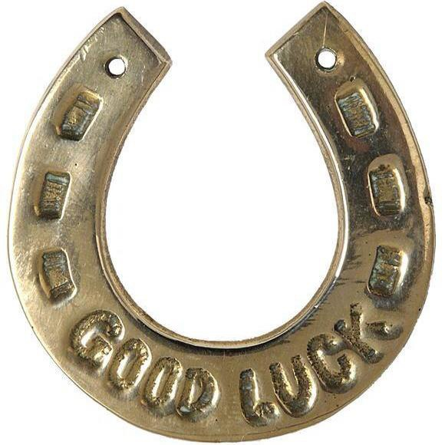

OPEN TO ALL RIDDEN CHAMPIONS FROM PROSTON,
GOOMERI, KINGAROY, NANANGO, BLACKBUTT
AND WONDAI SHOWS

SPONSORS
Retschlag Family
Hair Cuts on Haly
Norco Stock Feeds
Ryan’s Butchery
Retschlag’s on Farm Butchering
Riverina Stock Feeds
Deb Frecklington MP
Cheryl Dunstan
Cr Ros Heit
Cr Kathy Duff
Breeze Country Candles
Lady B Accessories
Bochmann Transport
Wondai Accounting & Tax

2019 WONDAI SHOW – Horse Section
Camping & Stabling

All Campers must have own power for Friday & Saturday nights.
Camping – free for 2 nights of Show; then $15 per vehicle per night (Car & float/gooseneck is counted as 1 unit)

Cheques payable to Wondai A P & I Society Inc.
Direct deposit can be made to:
Account Name: Wondai A P & I Society Inc
BSB- 633000 Account- 1593 52418
Reference your last name followed by the word ‘horses’

Extra Camping Yes

No

No. of units

No. of nights

Stabling - free for the duration of the Show

No. of stables

Please indicate the sex of the horses being stabled.

Mares/Fillies

Geldings

Stallions/Colts

Send your bookings to Lorraine Retschlag
PO Box 159 Wondai QLD 4606
or email: secretary@wondaishow.com.au

EQUESTRIAN WAIVER

Wondai AP&I Society Inc
I _____________________________ of ___________________________________________

Phone _______________________ Fax _______________ Email ______________________

Hereby Agree to:
1. Indemnify Wondai AP&I Society Inc against any liability whatsoever for any injury loss or damage sustained by me, my horse or my equipment at the Wondai Show.
2. Compete and exhibit at the Wondai at my own risk entirely.
3. Forfeit any right to any claim, demand or action against Wondai AP&I Society Inc or related bodies arising out of the conduct of the Wondai Show
4. Declare my horse and equipment are in sound condition.
5. Consent to receiving any medical treatment including ambulance transportation that event organisers think desirable as required during the event.
6. I have read the contents and fully understand all details of this form. I am 18 years of age or over.

Dated at………………………………this…………………day of…………………………………..20…..

Competitor / Exhibitor Witness………………………………………

As a parent or guardian of the Competitor/Exhibitor who is under the age of 18 years, I agree to the above for myself and on behalf of my child I indemnify and keep indemnified all people and corporations associated with the conduct of the event on the terms referred to.

Dated at………………………………this…………………day of............................................20…..

Parent/Guardian Witness

I ACKNOWLEDGE THAT I HAVE READ THIS FORM OR THAT IT HAS BEEN EXPLAINED TO ME. I FULLY UNDERSTAND ITS TERMS AND THAT I HAVE GIVEN UP SUBSTANTIAL RIGHTS BY SIGNING IT. I HAVE SIGNED THE DOCUMENT FREELY AND VOLUNTARILY WITHOUT ANY INDUCEMENT MADE TO ME AND INTEND MY SIGNATURE TO BE A COMPLETE AND UNCONDITIONAL RELEASE OF ALL LIABILITY TO THE GREATEST EXTENT ALLOWED BY LAW

The QCAS horse health declaration form can be downloaded from the QCAS web site.

