Cootamundra APH & I Association Inc
Cootamundra 7th Annual
All Breeds Foal
&
Youngstock Show
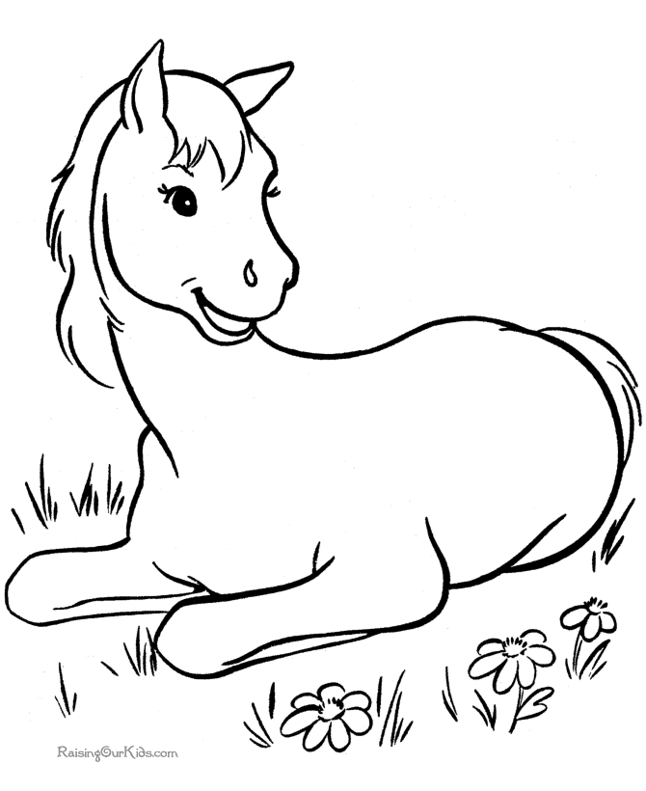

Sunday 10 June 2018
Cootamundra Showgrounds (Entry Pinkerton Road)
All Rings Commence at 10am
Entry fee: $4 per class by ticket
Horse Numbers $2 per horse (compulsory)
Free Gate Entry
3 Shows 1 Weekend
Saturday Cootamundra Winter Show
Sunday WPCS Western RPG Welsh Youngstock Show
Enquiries: Bec Medhurst 0402 465 239 nordicparkstud@gmail.com
Stables/Camping: Jen Elmes jenelmes@bigpond.com
RULES AND REGULATIONS
EXHIBITS
- All foals must be weaned. No wet mares will be allowed into the ring or on the grounds.
- Colts 2 years of age and over must be bitted.
- Unruly behaviour by any exhibit may be penalised – excessive unruly behaviour may bring expulsion from the ring for that class, as safety must be the first consideration.
- Exhibits in classes for geldings must have been gelded.
- Exhibits registered as geldings are not eligible to compete in colt classes.
- Horses competing must consent to drug testing if required on the day.
- NO Riding of any horses on the grounds AFTER 9.30am. Please be respectful when riding prior to this time as there will be a number of exhibits experiencing their first show. Please do not ride horses where others are lunging or walking their horses.
- Exhibits must choose between Open or Show Hunter classes and only compete in one.
ENTRY & DISCLAIMERS
- Owners/exhibitors entering exhibits do so entirely at their own risk and it is a condition of entry that no liability of any kind attaches itself to the Cootamundra APH & I, officials or members in any respect whatsoever.
- The Committee reserves the right to split classes if sufficient entries on the day.
- All exhibits must be under control at all times.
- A judge may refuse to judge an exhibit that he/she considers to be unsound.
- Entry per class is $4. Class entry will be via tickets available near the ring
- Horse Numbers will be $2 per horse and is compulsory and non-refundable. There will be no gate entry fee to the grounds
- All exhibitors must sign indemnity and disclaimer forms prior to entering the ring.
- Any spectator/handler/helper wishing to be on the arena MUST sign a disclaimer.
REGISTRATION/MEMBERSHIP
- All youngstock (including foals) MUST be currently registered in the CURRENT OWNERS NAME with their respective Breed/Colour Society (proof of registration WILL be requested on the day – please bring a photocopy of the registration/s), owners must be current members of that Breed/Colour Society where required. Proof of membership must be able to be shown on the day.
CLIPPING, TRIMMING, PLAITING & PRESENTATION
- Foals and all youngstock must be exhibited as per their Breed Society regulations and Standard of Excellence. This includes plaiting, clipping and dyeing.
EXHIBITOR CONDUCT
- Any exhibitor whose conduct is considered to be ill mannered, aggressive or unsportsmanlike may be issued with a warning and subsequently dismissed from the class/disqualified and asked to leave the showgrounds.
- The judge’s decision is final - no person shall directly approach a judge with regard to a decision. Once a class has been judged, it cannot be re-judged.
- Lunging is not permitted in or near the marshalling area or vehicles
CLASSES
- The Youngstock Show will not commence until ALL Foal Show classes are completed.
- Please marshal well in advance of your class. It is your responsibility to keep an eye on the progress of the rings.
- Once a judge has commenced judging a class, no animal may enter the ring or be taken out of the ring without the permission of the judge (request made via steward).
- Classes with the exception of Champion and Supreme classes will not be held.
- Youngstock classes are for yearling to 3 year old horses.
- Foal classes are for horses less than 1 year of age.
- Horses age shall be calculated as at 1 August.
STABLING/YARDS & CAMPING
- Stabling/Yard facilities and powered camping are available at the showgrounds. Stables $20 per night, Uncovered /Outside Yards are $10 per night, powered camping $15 per night, unpowered camping $10 per night. There are only 10 lock up stables and preference will be given for large stallions or colts 2 years of age or over for these for bookings prior to 15 May. After this date bookings for other horses will be accepted for the stables. Bookings and payment MUST BE made prior to the show and payment is required to confirm your booking. All bookings to be completed on camping/stabling booking form. Please contact Jen Elmes
- Stable/yard bookings will only be accepted for horses and competitors residing 60km or more from Cootamundra Post Office.
- You are able to bring your own portable yards for the show but NO electric tape or units are allowed on the grounds. Please check with committee prior to erecting these yards.
- No refunds will be made for change of mind or unable to attend bookings.
- If we are unable to provide you with horse accommodation you will be provided a refund.
- Stable/Yard/Camping bookings close on 5 June and will be on a first in first served basis with payment and forms received.
RIBBON RAFFLE
- A ribbon raffle will be conducted on the day. Please return your ribbons for a ticket to go into the draw to win a bag of Conquerors Horse Pellets.
CANTEEN
- A canteen will operate on the day with hot and cold refreshments available
- PHOTOGRAPHERS
Rivendell Photography will be on the grounds over the weekend.
- No professional photography allowed without prior approval of the committee.

RING 1: Start 10.00 am Judge: Andrew Thorek

Best Presented Classes are not eligible for Champion. They are eligible for Best Presented Foal or Youngstock of The Show.

AUSTRALIAN PONY FOALS - must be registered in the PUREBRED Australian Pony Section of the APSB
- Best Presented
- Colt or Gelding
- Filly
Champion & Reserve Champion Australian Pony Foal
Sashes Provided by APSB NSW Society
$15 Prizemoney for Champion donated by Mahogany Park Pony Stud
Champion Eligible for Supreme Pony Breed Foal to be judged in Ring 2

PARTBRED APSB/APSB RIDING PONY
- Best Presented
- Colt or Gelding
- Filly
Champion & Reserve Champion Partbred APSB/APSB RP Foal
Champion to receive a bag of Conquerors Cool & Healthy Horse Pellets
Champion Eligible for Supreme Pony Breed Foal to be judged in Ring 2

ARABIAN DERIVATIVE FOALS
- Best Presented Arabian Derivative Foal
- Best Arabian Derivative Foal Head
- Best Arabian Derivative Trot

ARABIAN DERIVATIVE FOALS (may be split if numbers warrant)
- Colt or Gelding
- Filly
Champion & Reserve Champion Arabian Derivative Foal
Sashes Sponsored by Gemsfield Arabian Derivatives – Cowra NSW
Champion to receive a bag of Conquerors Cool & Healthy Horse Pellets
Champion eligible for Grand Champion Foal of the Show

SMALL BREEDS all ponies ne 10.2hh
Must be registered with a relevant society

- Best Presented Miniature Breed Foal
- Best Coloured Miniature Breed Foal

MINIATURE HORSE FOALS (Not exceeding 30”)
- Colt Foal
- Filly Foal
- Gelding Foal
Champion & Reserve Champion Miniature Horse Foal
Champion to receive a prize
MINIATURE PONY FOALS (Not exceeding 30”)
- Colt Foal
- Filly Foal
- Gelding Foal
Champion & Reserve Champion Miniature Pony Foal
Sashes Sponsored by Miniranch Mini Ponies
Champion to receive a bag of Conqueror Cool & Healthy Horse Pellets

SHETLAND PONY FOALS (APSB Registered)
- Best Presented
- Colt / Gelding
- Filly
Champion & Reserve Champion Shetland Pony Foal
Champion to receive a prize

ANY OTHER MINIATURE FOAL(must be registered) Not already catered for
- Colt Foal
- Filly Foal
- Gelding Foal
Champion & Reserve Champion Any other Miniature Foal
Champion to receive a prize

SUPREME SMALL BREED FOAL ne 10.2hh
Supreme to receive a bag of Conqueror Cool & Healthy Horse Pellets

MAJOR AWARDS - FOAL SHOW
To be judged by all judges at the completion of all Foal Show classes in all Rings.
Ring to be advised on day.

BEST PRESENTED FOAL OF SHOW
Winners of all Best Presented Foal Classes eligible to compete.
Sash & Garland Sponsored by Medhurst Family

GRAND CHAMPION FOAL OF SHOW
Winner to receive $100 prizemoney, Sash and Garland sponsored by The GEO Group
Grand Champion to receive a 10kg Tub of GT Performer
All Supreme Foal Exhibits eligible to compete plus Champions where stated

Dr Geoff from GT Performer will be available on the weekend to discuss his fantastic products including GT Performer, GT Elite & GT Performer Canine, with stock available to purchase

YOUNGSTOCK CLASSES WILL NOT COMMENCE UNTIL THE COMPLETION OF JUDGING THE FOAL CLASSES IN ALL RINGS.

AUSTRALIAN PONY YOUNGSTOCK - must be registered in the PUREBRED AUSTRALIAN PONY Section of the APSB
- Best Presented (not eligible for champion but eligible for Best presented Youngstock of the Show)
- Colt yearling to 3yo
- Yearling Filly/Gelding
- 2 & 3 yr Gelding
- 2 & 3 yr Filly
Champion & Reserve Champion Australian Pony Youngstock
Sashes Provided by APSB NSW Branch
$15 prizemoney for Champion donated by Mahogany Park Pony Stud
Champion Eligible for Supreme Pony Breed Youngstock to be judged in Ring 2

PARTBRED APSB or APSB RIDING PONY YOUNGSTOCK
- Best Presented (not eligible for champion but eligible for Best presented Youngstock of the Show)
- Yearling
- 2 year old
- 3 year old
Champion & Reserve Champion Partbred APSB or APSB RP Youngstock
Champion to receive a bag of Conqueror Cool & Healthy Horse Pellets
Champion Eligible for Supreme Pony Breed Foal to be judged in Ring 2

ARABIAN DERIVATIVE YOUNGSTOCK
- Best Presented Arabian Derivative Youngstock
- Yearling, 2 & 3 yrs Best Head
- Yearling, 2 & 3 yrs Best Trot

YEARLING ARABIAN DERIVATIVES
- Yearling Anglo or Arabian Warmblood Filly
- Yearling Anglo or Arabian Warmblood Gelding
- Yearling Partbred, Quarab or Arabian Stockhorse Filly
- Yearling Partbred, Quarab or Arabian Stockhorse Gelding
- Yearling Arabian Pony or Arabian Riding Pony Filly
- Yearling Arabian Pony or Arabian Riding Pony Gelding
- Yearling Derivative Colt – any of the above AHSA registry (may be split)
Champion & Reserve Champion Yearling Arabian Derivative
Sashes Sponsored by Gemsfield Arabian Derivatives – Cowra NSW
Champion to receive a bag of Conquerors Cool & Healthy Horse Pellets
Champion eligible for Grand Champion Yearling

2 YEAR OLD ARABIAN DERIVATIVES
- 2yo Anglo, Arabian Warmblood, Partbred, Quarab or Arabian Stockhorse Filly
- 2yo Anglo, Arabian Warmblood, Partbred, Quarab or Arabian Stockhorse Gelding
- 2yo Arabian Pony or Arabian Riding Pony Filly
- 2yo Arabian Pony or Arabian Riding Pony Gelding
- 2yo Arabian Derivative Colt – any of the above AHSA registry (may be split)
Champion & Reserve Champion 2 year old Arabian Derivative
Sashes Sponsored by Gemsfield Arabian Derivatives – Cowra NSW
Champion to receive a bag of Conquerors Cool & Healthy Horse Pellets
Champion eligible for Grand Champion 2yo

3 YEAR OLD ARABIAN DERIVATIVES
- 3yo Anglo, Arabian Warmblood, Partbred, Quarab or Arabian Stockhorse Filly
- 3yo Anglo, Arabian Warmblood, Partbred, Quarab or Arabian Stockhorse Gelding
- 3yo Arabian Pony or Arabian Riding Pony Filly
- 3yo Arabian Pony or Arabian Riding Pony Gelding
- 3yo Arabian Derivative Colt – any of the above AHSA registry (may be split)
Champion & Reserve Champion 3 year old Arabian Derivative
Sashes Sponsored by Gemsfield Arabian Derivatives – Cowra NSW
Champion to receive a bag of Conquerors Cool & Healthy Horse Pellets
Champion eligible for Grand Champion 3 yo

SMALL BREED YOUNGSTOCK CLASSES ne 10.2hh
Must be registered with a relevant society

- Best Presented Small Breed Youngstock
- Best Coloured Small Breed Youngstock
MINIATURE HORSE YOUNGSTOCK
- Yearling Colt (n.e 32”)
- 2 & 3 yo Colt (n.e 34.5”)
- Yearling Filly (n.e 32”)
- 2 & 3 yo Filly (n.e 34.5”)
- 3 yr & under Gelding (n.e 34.5”)
Champion & Reserve Champion Miniature Horse Youngstock
Champion to receive a prize

MINIATURE PONY YOUNGSTOCK
- Yearling Colt (n.e 32”)
- 2 & 3 yo Colt (n.e 34.5”)
- Yearling Filly (n.e 32”)
- 2 & 3 yo Filly (n.e 34.5”)
- 3 yr & under Gelding (n.e 34.5”)
Champion & Reserve Champion Miniature Pony Youngstock
Sashes Sponsored by Miniranch Mini Ponies
Champion to receive a bag of Conqueror Cool & Healthy Horse Pellets

SHETLAND PONY YOUNGSTOCK (APSB Registered)
- Best Presented (not eligible for champion but eligible for Best presented Youngstock of the Show)
- Colt 3 & under
- Yearling Filly/Gelding
- 2 & 3yo Gelding
- 2 & 3yo Filly
Champion & Reserve Champion Shetland Pony Youngstock
Champion to receive a prize

ANY OTHER MINIATURE BREED not already catered for
Classes may be split if numbers require
- 3yrs & Under Colt
- 3yrs & Under Filly
- 3yrs & Under Gelding
Champion & Reserve Champion Any other Miniature Breed Youngstock not already catered for
Champion to receive a prize

SUPREME SMALL BREED YOUNGSTOCK ne 10.2hh
Supreme to receive a bag of Conqueror Cool & Healthy Horse Pellets

RING 1 GROUP CLASSES (foals & youngstock eligible)
- Owners group of 2 youngstock from breeds in Ring 1
- Sire or Dam Progeny group of 2 youngstock from Breeds in Ring 1

MAJOR AWARDS – YOUNGSTOCK SHOW

To be judged by all judges at the completion of all Youngstock classes in all Rings.

BEST GROUP OF 2 YOUNGSTOCK OF SHOW
Winning Group to receive Sashes and Flower Halter Rosettes
donated by The Medhurst Family
Winners of Group classes eligible to compete

BEST PRESENTED YOUNGSTOCK OF SHOW
Winner to receive Sash & Garland donated by Medhurst Family
Winners of all Best Presented Youngstock Classes eligible to compete.

GRAND CHAMPION YEARLING EXHIBIT
Winner to receive $100 prize money & Sash donated by Cootamundra Cleaning
Grand Champion to receive a 10kg Tub of GT Performer
Yearling winners of ALL classes eligible to compete

GRAND CHAMPION 2 YEAR OLD EXHIBIT
Winner to receive $100 prize money & Sash donated by Towers Family
Grand Champion to receive a 10kg Tub of GT Performer
2 year old winners of ALL classes eligible to compete

GRAND CHAMPION 3 YEAR OLD EXHIBIT
Winner to receive $100 prize money & Sash donated by Cootamundra Ex-Services Club
Grand Champion to receive a 10kg Tub of GT Performer
3 year old winners of ALL classes eligible to compete

Cathy’s Browbands will be on the grounds on the weekend with lots of her gorgeous browbands available. A great opportunity to have a chat to Cathy.

RING 2: Start 10 am Judge: Julie Tonkin

Best Presented are not eligible for champion but are eligible for Best Presented Foal or Youngstock of The Show

LARGE BREED FOAL CLASSES

ANSA (AUSTRALIAN NATIONAL SADDLEHORSE ASSOCIATION)
- Best Presented
- Colt/Gelding
- Filly
Champion & Reserve Champion ANSA Foal
Sashes provided by ANSA
Champion to receive a prize

AUSTRALIAN STOCK HORSE FOAL (ASH)
- Best Presented
- Colt or Gelding
- Filly
Champion & Reserve Champion ASH Foal
Sashes sponsored by Secretheart ASH
Champion to receive a bag of Conquerors Cool & Healthy Horse Pellets

ANY OTHER LARGE BREED FOAL (NOT PREVIOUSLY MENTIONED INCL HEAVY HORSES)
- Best Presented
- Colt or Gelding
- Filly
Champion & Reserve Champion Any Other Large Breed Foal
Sashes sponsored by Cootamundra Cleaning
Champion to receive a bag of Conquerors Cool & Healthy Horse Pellets

SUPREME LARGE BREED FOAL OF SHOW
Supreme to receive a Bag of Conqueror Cool & Healthy Horse Pellets
Supreme Eligible for Grand Champion Foal

PONY BREED FOAL CLASSES

RIDING PONY FOALS - must be registered with the RPSBS
- Best Presented
- Colt or Gelding
- Filly
Champion & Reserve Champion Riding Pony Foal
Champion to receive a prize

AUSTRALIAN SADDLE PONY FOALS
- Best Presented
- Colt or Gelding
- Filly
Champion & Reserve Champion Australian Saddle Pony Foal
Sashes Provided by ASPA
$15 for Champion Sponsored by Eastview Equestrian

SUPREME PONY BREED FOAL OF SHOW
Supreme to receive a bag of Conqueror Cool & Healthy Horse Pellets
Supreme Eligible for Grand Champion Foal

MAJOR AWARDS - FOAL SHOW

To be judged by all judges at the completion of all Foal Show classes in all Rings.
Ring to be advised on day.

BEST PRESENTED FOAL OF SHOW
Winners of all Best Presented Foal Classes eligible to compete.
Sash & Garland Sponsored by Medhurst Family

GRAND CHAMPION FOAL OF SHOW
Winner to receive $100 prize money, sash & Garland sponsored by The GEO Group
Grand Champion to receive a 10kg Tub of GT Performer
All Supreme Foal Exhibits eligible to compete & Champions where stated

Thank you to the following breed societies for their support:

- APSB NSW Branch | - WPCS Western NSW RPG
- Dilutes Australia – NSW & ACT  - ASPA | - ANSA
YOUNGSTOCK CLASSES WILL NOT COMMENCE UNTIL THE COMPLETION OF JUDGING THE FOAL CLASSES IN ALL RINGS.

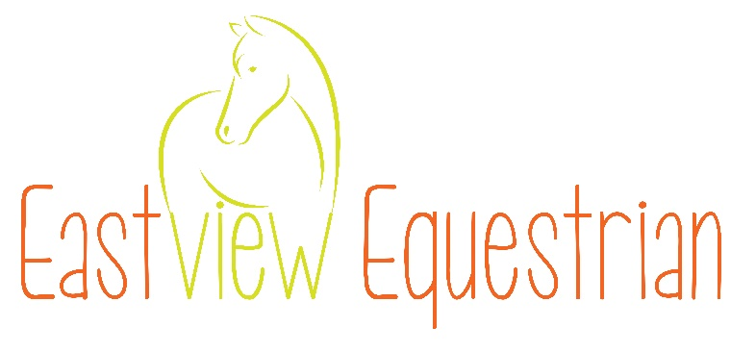
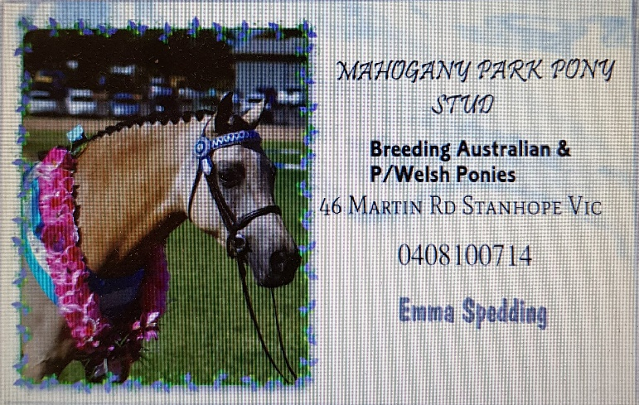

LARGE BREEDS YOUNGSTOCK

Purebred Arabian
- Best Presented Pure Arabian Youngstock (not eligible for champion)
- Yearling, 2 & 3 yo Colt
- Yearling, 2 & 3 yo Filly
- Yearling, 2 & 3yo Gelding
Champion & Reserve Champion Purebred Arabian Youngstock
Sashes Sponsored by Devizes Arabians
Champion to receive a bag of Conqueror Cool & Healthy Horse Pellets

ANSA (AUSTRALIAN NATIONAL SADDLEHORSE ASSOCIATION)
- Best Presented ANSA Youngstock (not eligible for champion)
- Yearling, 2 & 3 yo Colt
- Yearling Filly / Gelding
- 2 & 3 yr Filly
- 2 & 3 yr Gelding
Champion & Reserve Champion ANSA Youngstock
Sashes provided by ANSA
$15 prizemoney for Champion donated by Waratah Show Horses

AUSTRALIAN STOCK HORSE
- Best Presented ASH (not eligible for champion)
- Yearling, 2 & 3 yo Colt
- Yearling - Filly / Gelding
- 2 yo Gelding
- 3 yo Gelding
- 2yo Filly
- 3yo Gelding
Champion & Reserve Champion ASH Youngstock
Sashes Sponsored by Jenny Coleman
Champion to receive a bag of Conquerors Cool & Healthy Horse Pellets

HEAVY BREED YOUNGSTOCK
- Best Presented Heavy Breed Youngstock (not eligible for champion)
- Yearling, 2 & 3 yo Colt
- Yearling, 2 & 3yo Filly
- Yearling, 2 & 3yo Gelding
Champion & Reserve Champion Heavy Breed Youngstock
Sashes Sponsored by Cootamundra Cleaning
Champion to receive a prize

ANY OTHER LARGE BREED YOUNGSTOCK (not mentioned in schedule)
- Best Presented Any Other Large Breed Youngstock
- Colt 3 yrs & under
- Filly 3 yrs & under
- Gelding 3 yrs & under
Champion & Reserve Champion Any Other Large Breed Youngstock
Sashes Sponsored by Cootamundra Cleaning
Champion to receive a bag of Conqueror Cool & Healthy Horse Pellets

SUPREME LARGE BREED YOUNGSTOCK EXHIBIT
Embroidered rug donated by Supreme Choice Horsewear

PONY YOUNGSTOCK SHOW

RIDING PONY YOUNGSTOCK – must be registered with the RPSBS
- Best Presented (not eligible for champion but eligible for Best presented Youngstock)
- Yearling Colt or Gelding ne 13.3 1/2hh
- Yearling Filly ne 13.3 1/2hh
- 2 yo Colt ne 14 1/2hh, 3yo Colt ne 14.1 1/2h
- 2 yo Gelding ne 14 1/2hh
- 3 yo Gelding ne 14 1 1/2hh
- 2 yo Filly ne 14 1/2hh
- 3 yo Filly ne 14.1 1/2hh
Champion & Reserve Champion RPSB Riding Pony Youngstock
Sashes sponsored by David & Matt Hall
Champion to receive a bag of Conquerors Cool & Healthy Horse Pellets

AUSTRALIAN SADDLE PONY YOUNGSTOCK
- Best Presented (not eligible for champion but eligible for Best presented Youngstock of the Show)
- Yearling to 3yo Colt
- Yearling Gelding
- Yearling Filly
- 2 & 3 yr old Filly
- 2yo Gelding
- 3yr old Gelding
Champion & Reserve Champion Australian Saddle Pony Youngstock
Sashes Provided by ASPA
$15 prize money donated by SImpfendorfer Family

SUPREME PONY YOUNGSTOCK EXHIBIT
The Marnic Merrymaid Memorial Award
Presented by Stevenson Family Show Stables
Supreme to receive a Bag of Conqueror Cool & Healthy Horse Pellets
Champion Pony Breeds from Rings 1, 2 & 3 eligible

RING 2 YOUNGSTOCK GROUP CLASSES (Foals & Youngstock eligible)
- Sire or Dams Progeny Group of 2 Youngstock from breeds in Ring 2
- Owners Group of 2 Youngstock from breeds in Ring 2

SHOW HUNTER LED CLASSES – For youngstock to mature as a Show Hunter
- Show Hunter Pony to mature ne 12hh
- Show Hunter Pony to mature 12 ne 13hh
- Show Hunter Pony to mature 13 ne 14hh
- Show Hunter Galloway to mature 14 ne 15hh
- Show Hunter Hack to mature over 15hh
Champion & Reserve Champion Led Show Hunter Youngstock
Sashes sponsored by David & Matt Hall
Champion to receive a bag of Conqueror Cool & Healthy Horse Pellets
OPEN LED CLASSES – For youngstock to mature as an Open type of Show Horse
- Open Pony to mature ne 12hh
- Open Pony to mature 12 ne 13hh
- Open Pony to mature 13 ne 14hh
- Open Galloway to mature 14 ne 15hh
- Open Hack to mature over 15hh
Champion & Reserve Champion Led Open Youngstock
Sashes sponsored by Simpfendorfer Family
Champion to receive a bag of Conqueror Cool & Healthy Horse Pellets

MAJOR AWARDS – YOUNGSTOCK SHOW

To be judged by all judges at the completion of all Youngstock classes in all Rings.

BEST GROUP OF 2 YOUNGSTOCK OF SHOW
Winning Group to receive Sashes and Flower Halter Rosettes
donated by The Medhurst Family
Winners of Group classes eligible to compete

BEST PRESENTED YOUNGSTOCK OF SHOW
Winner to receive Sash & Garland donated by Medhurst Family
Winners of all Best Presented Youngstock Classes eligible to compete.

GRAND CHAMPION YEARLING EXHIBIT
Winner to receive $100 prize money & Sash donated by Cootamundra Cleaning
Grand Champion to receive a 10kg Tub of GT Performer
Yearling winners of ALL classes eligible to compete

GRAND CHAMPION 2 YEAR OLD EXHIBIT
Winner to receive $100 prize money & Sash donated by Towers Family
Grand Champion to receive a 10kg Tub of GT Performer
2 year old winners of ALL classes eligible to compete

GRAND CHAMPION 3 YEAR OLD EXHIBIT
Winner to receive $100 prize money & Sash donated by Cootamundra Ex-Services Club
Grand Champion to receive a 10kg Tub of GT Performer
3 year old winners of ALL classes eligible to compete
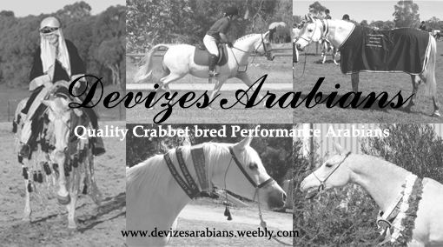
RING 3 – Start 10am Judge: Michelle Styles

Best Presented not eligible for Champion but eligible for Best Presented Foal or Youngstock of the Show

ANY COLOURED BREED FOAL (must be registered with a recognised colour society/association)
- Best Presented (not eligible for Champion)
- Colt
- Filly
- Gelding
Champion & Reserve Champion Any Coloured Breed Foal
Sashes Provided by Dilutes Australia- NSW & ACT Branch
$15 prizemoney for Champion donated by Secretheart ASH
Champion eligible for Grand Champion Foal of the Show

Western NSW RPG will be running a Welsh Show at the grounds on the same day. Pure & Part Welsh have a chance of performances at 2 shows on the same day. Same horses numbers, same tickets for both shows.

WELSH MOUNTAIN PONY (SECTION A) FOALS
- Best Presented Welsh A Foal
- Colt
- Filly
Champion & Reserve Champion Welsh Mountain Pony (Section A) Foal
Sashes provided by WPCS Western NSW RPG
$15 prize money for Champion donated by Linden Stud

WELSH PONY (SECTION B) FOALS
- Best Presented Welsh B Foal
- Colt
- Filly
Champion & Reserve Champion Welsh Pony (Section B) Foal
Sashes provided by WPCS Western NSW RPG
$15 prize money for Champion donated by Cootamundra Cleaning

WELSH SECTION C FOALS
- Best Presented Welsh C Foal
- Colt
- Filly
Champion & Reserve Champion Welsh Section C Foal
Sashes provided by WPCS Western NSW RPG
$15 prize money for Champion donated by Cootamundra Cleaning

WELSH SECTION D FOALS
- Best Presented Welsh D Foal
- Colt
- Filly
Champion & Reserve Champion Welsh Section D Foal
Sashes provided by WPCS Western NSW RPG
Champion to receive a bag of Conquerors Cool & Healthy Horse Pellets

WELSH SECTION E FOALS
- Best Presented Section E Gelding
- Gelding of Section A Breeding
- Gelding of Section B Breeding
- Gelding of Section C or D Breeding
Champion & Reserve Champion Welsh Section E Geldings
Sashes provided by WPCS Western NSW RPG
$15 prize money for Champion donated by Linden Stud

SUPREME PURE WELSH FOAL OF THE SHOW
Sash provided by WPCS Western NSW RPG
Garland provided by Regazza Show Ponies
Winner eligible for Grand Champion Foal

PART WELSH FOALS
- Best Presented
- Colt
- Filly
- Gelding
Champion & Reserve Champion Part Welsh Foal
Sashes provided by WPCS Western NSW RPG
$15 prize money for Champion donated by Prada Pines Pony Stud
Champion eligible for Supreme Pony Breed Foal to be held in Ring 2

MAJOR AWARDS - FOAL SHOW

To be judged by all judges at the completion of all Foal Show classes in all Rings.
Ring to be advised on day.

BEST PRESENTED FOAL OF SHOW
Winners of all Best Presented Foal Classes eligible to compete.
Sash & Garland Sponsored by Medhurst Family

GRAND CHAMPION FOAL OF SHOW
Winner to receive $100 prize money, Sash and Garland sponsored by The GEO Group
Grand Champion to receive a 10kg Tub of GT Performer
All Supreme Foal Exhibits eligible to compete and Champions where stated

YOUNGSTOCK CLASSES WILL NOT COMMENCE UNTIL THE COMPLETION OF JUDGING THE FOAL CLASSES IN ALL RINGS.

COLOURED BREEDS YOUNGSTOCK (must be registered with a recognised colour society/association)
- Best Presented Any Coloured
- Yearling Colt
- 2 or 3 yo colt
- Yearling Filly
- Yearling Gelding
- 2 or 3yo Filly
- 2 or 3yo Gelding
Champion & Reserve Champion Coloured Breeds Youngstock
Sashes Provided by Dilutes Australia- NSW & ACT Branch
$15 prize money for Champion donated by Jenny Coleman
Champion eligible for Grand Champion Youngstock of the Show

WELSH YOUNGSTOCK

Western NSW RPG will be running a Welsh Show at the grounds on the same day. Pure & Part Welsh have a chance for performances at 2 shows on the same day. Same horses numbers, same tickets for both shows.

WELSH MOUNTAIN PONY (SECTION A)
- Best Presented Welsh A
- Yearling Filly
- 2 & 3 yr Filly
- 3 yr & under Colt (may be split if numbers warrant)
Champion & Reserve Champion Welsh Mountain Pony (Section A) Youngstock
Sashes provided by WPCS Western NSW RPG
$15 prize money for Champion donated by Holburn Park Ponies

WELSH PONY (SECTION B)
- Best Presented Welsh B
- Yearling Filly
- 2 & 3 yr Filly
- 3 yr & under Colt (may be split if numbers warrant)
Champion & Reserve Champion Welsh Pony (Section B) Youngstock
Sashes provided by WPCS Western NSW RPG
$15 prize money for Champion donated by Douglas Photographics

WELSH SECTION C
- Best Presented Welsh C
- Yearling Filly
- 2 & 3 yr Filly
- Yearling to 3yo Colt (may be split if numbers warrant)
Champion & Reserve Champion Welsh Section C Youngstock
Sashes provided by WPCS Western NSW RPG
Champion to receive a bag of Conquerors Cool & Healthy Horse Pellets

WELSH SECTION D
- Best Presented Welsh D
- Yearling Filly
- 2 & 3 yr Filly
- Yearling to 3yo Colt (may be split if numbers warrant)
Champion & Reserve Champion Welsh Section D Youngstock
Sashes provided by WPCS Western NSW RPG
$15 prize money for Champion donated by Douglas Photographics

WELSH SECTION E GELDINGS YOUNGSTOCK
- Best Presented Welsh Section E
- Yearling Gelding of Section A Breeding
- 2 or 3yo Gelding of Section A Breeding
- Yearling Gelding of Section B Breeding
- 2 or 3yo Gelding of Section B Breeding
- Yearling Gelding of Section C or D Breeding
- 2 or 3yo Gelding of Section C or D Breeding
Champion & Reserve Champion Welsh Section E Gelding
Sashes provided by WPCS Western NSW RPG
$15 prize money for Champion donated by Douglas Photographics

SUPREME PURE WELSH YOUNGSTOCK OF THE SHOW
Sash provided by WPCS Western NSW RPG
Garland provided by Regazza Show Ponies
Winner eligible for Grand Champion Youngstock of the Show

PART WELSH YOUNGSTOCK
- Best Presented Part Welsh Youngstock (not eligible for champion)
- Yearling Filly
- Yearling Gelding
- Yearling, 2 or 3yo Colt
- 2 yo Gelding
- 2 yo Filly
- 3yo Gelding
- 3yo Filly
Champion & Reserve Champion Part Welsh Youngstock
Sashes provided by WPCS Western NSW RPG
Champion to receive a bag of Conquerors Cool & Healthy Horse Pellets
Champion eligible for Supreme Pony Breed Youngstock to be held in Ring 2

RING 3 YOUNGSTOCK GROUP CLASSES (Foals & Youngstock eligible)
- Owners Group of 2 Youngstock from breeds in Ring 3
- Dam or Sires progeny Group of 2 Youngstock from breeds in Ring 3

MAJOR AWARDS – YOUNGSTOCK SHOW

To be judged by all judges at the completion of all Youngstock classes in all Rings.

BEST GROUP OF 2 YOUNGSTOCK OF SHOW
Winning Group to receive Sashes and Flower Halter Rosettes
donated by The Medhurst Family
Winners of Group classes eligible to compete

BEST PRESENTED YOUNGSTOCK OF SHOW
Winner to receive Sash & Garland donated by Medhurst Family
Winners of all Best Presented Youngstock Classes eligible to compete.

GRAND CHAMPION YEARLING EXHIBIT
Winner to receive $100 prize money & Sash donated by Cootamundra Cleaning
Grand Champion to receive a 10kg Tub of GT Performer
Yearling winners of ALL classes eligible to compete

GRAND CHAMPION 2 YEAR OLD EXHIBIT
Winner to receive $100 prize money & Sash donated by Towers Family
Grand Champion to receive a 10kg Tub of GT Performer
2 year old winners of ALL classes eligible to compete

GRAND CHAMPION 3 YEAR OLD EXHIBIT
Winner to receive $100 prize money & Sash donated by Cootamundra Ex-Services Club
Grand Champion to receive a 10kg Tub of GT Performer
3 year old winners of ALL classes eligible to compete

SPONSORS
Thank you to the following sponsors of our show. Without your support this show would not be possible.
- Conqueror Milling  - Cathys Browbands | - Devizes Arabians  - Eastview Equestrian
- Mahogany Park Pony Stud | - Regazza Show Ponies
- Prada Pines Pony Stud | - Cootamundra Ex Services Club
- The Geo Group Australia Pty Ltd | - Smartfix Auto Electrics
- Stevenson Family Show Stables | - Douglas Photographics
- Secretheart ASH | - Towers Family
- Gemsfield Arabian Derivatives | - GT Performer
- Simpfendorfer Family | - Tyre Designs
- Miniranch Mini Ponies | - Cootamundra Cleaning
- David & Matt Hall | - Supreme Choice Horsewear
- Waratah Show Horses | - Jenny Coleman
- Linden Stud | - Holburn Park Ponies
- David & Matt Hall | - Medhurst Family
