Trundle P & A Society Inc.
PO Box 16 Trundle NSW 2875 (www.mytrundle.com.au)

106th TRUNDLE SHOW
Wednesday, 17th August 2016
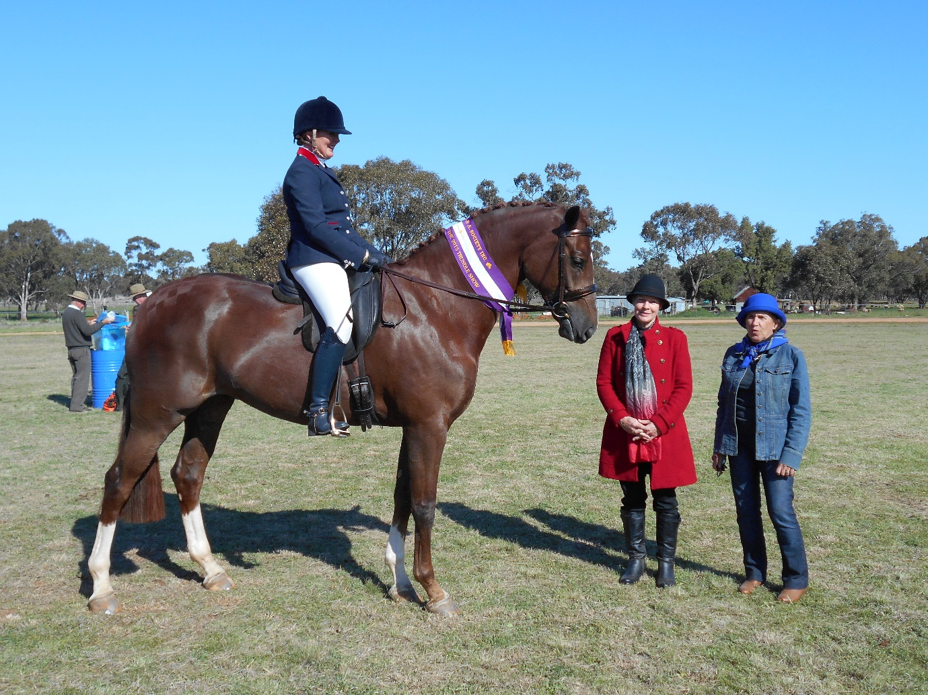

Major Event in Class A:
Supreme Hack of the Show - $120

Class A - Horses
Ringmaster: S. Wright, Telephone: (02) 68921391 (a.h.)
Assistant Ringmaster: T Quade, Telephone: (02) 68921231

Stewards: D. Simmons, D Quade, J Randall, Mat Randall, A. McGrath, Anita Medcalf, L Simmons, S. McDonald

All ring events on Wednesday of the Show
Major Event of Class A: Supreme Ridden Horse of the Show - $120

Condition
- Starting Time will be 9.00 am sharp
- All Exhibitors must pay admission or be a member.
- In the event of a dispute concerning height, horses shall be measured on a concrete slab on the grounds by the Society’s Official Measurer, whose decision shall be considered final and indisputable.
- All other disputes will be dealt with by the Dispute Committee, whose decision shall be considered final and indisputable.
- The Committee retains the right to all, alter or cancel any events. • Ponies are not permitted to compete in hack events or hack in pony events.
- Drug Testing For Horses – It is forbidden to administer any stimulant or depressant to a horse, or to cause one to be administered in any way whatsoever, whether before the start of a competition or on the previous day, under the maximum penalty of disqualification for life of the owner, rider, horse and groom. The Society may make, or cause to be made, any test of any exhibit to determine whether any drug or stimulant has been administered to such an exhibit, and may take possession of any such exhibit for any of the aforesaid purposes and detail such horse for such period as is deemed necessary.
- Radio controlled devices are not to be used on Showground during Show time.
- All riders must wear protective skull caps – Australian Standard.
- Appropriate footwear must be worn at all time when riding. This footwear must enable removal of the foot from the stirrup iron. It must also prevent the foot sliding forward and through the stirrup iron.
- Appropriate Attire to be worn in led-in classes.
- All local classes are for riders and horses living within 40 km.
- A Novice Hack is a horse which has not won
2
a first prize in a Hack Class at any show. • Stallions must be under the control of an adult at all times and be well behaved.
- Stallions are permitted to ride in the sporting events.
- Pleasure pony or horse to be ridden in a snaffle bit.
- Entry Fees will be $1-00 unless stated.
- Prize money will be 1st - $4-00 & 2nd - $2-00 • Horses competing in show hunter classes cannot compete in the open hack classes. • Horses competing in hacks classes cannot compete in show hunter classes. • Hunters & Hacks are eligible for Supreme
Ridden Horse of the Show Sporting Rules & Regulations
- All sporting events will be run as per Pony Club Rules
- These are timed events
- First three fastest times will receive a prize
- Each horse may have only one start in the event

RING 1
- Led Pony Gelding under 14 hands
- Led Pony Mare under 14 hands
Champion & Reserve Champion Led Pony
- Led rider under 8 years
- Rider 5 years or under
- Rider 6 & under 8 years
- Rider 8 & under 10 years

Champion & Reserve Champion Rider under 10 years
- Rider 10 & under 12 years
- Rider 12 & under 14 years
- Rider 14 & under 17 years

Champion & Reserve Champion Rider U17 yrs.
- Local Led rider under 8 years
- Local rider under 8 years
- Local rider 8 & under 12 years
- Local rider 12 & under 14 years
- Local rider 14 & under 17 years

Champion & Reserve Champion Local Junior Rider

- Novice Pony Hack under 14 hands
- Pony Hack under 12 hands
- Pony Hack 12 & under 12.2 hands
- Pony Hack 12.2 & under 13 hands
- Pony Hack 13 & under 13.2 hands
- Pony Hack 13.2 & under 14 hands
- Child's pony hack under 14 hands

22. Adult’s pony hack under 14 hands
Champion & Reserve Champion Pony Hack

- Pleasure Pony Hack under 14 hands snaffle bit only
- Novice Show Hunter Pony 14 hands & under
- Show Hunter Pony under 12 hands
- Show Hunter Pony 12 & under 14 hands
- Child's Show Hunter Pony under 14 hands
- Adult’s Show Hunter Pony under 14 hands
Champion/Reserve Champion Show Hunter Pony
- Pair of riders under 12 years
- Pair of riders 12 & under 17 years
- Adult & Child Rider

RING 2
- Led Galloway Gelding 14 & under 15 hands
- Led Galloway Mare 14 & under 15 hands
Champion & Reserve Champion Led Galloway

- Led Hack Gelding over 15 hands
- Led Hack Mare over 15 hands

Champion & Reserve Champion Led Hack

- Lady Rider 17 years & Over
- Local Lady rider 17 Years & Over within 40 km
- 39. Local Gentleman Rider 17 Years & Over within 40 km
Champion & Reserve Champion Rider over 17 years
38. Gentleman Rider 17 Years & over

- Novice Galloway 14 & under 15 hands
- Galloway Hack 14 & under 14.2 hands
- Galloway Hack 14.2 & under 15 hands
- Child's Galloway hack 14 & under 15 hands
- Adult’s Galloway 14 & under 15 hands

Champion & Reserve Champion Galloway

- Pleasure Galloway Hack 14 & under 15 hands-snaffle bit only
- Novice Show Hunter Galloway 14 hands & under 15
- Show Hunter Galloway 14 hands & under 14.2
- Show Hunter Galloway 14.2 hands & under 15
- Child’s Show Hunter Galloway 14 & under 15 hands
- Adult’s Show Hunter Galloway 14 & under 15 hands
Champion/Reserve Champion Show Hunter Galloway

- Novice Hack over 15 hands
- Hack 15 & under 15.2 hands
- Hack 15.2 & under 16 hands
- Hack 16 & under 16.2 hands
- Hack over 16.2 hands
- Child's Hack over 15 hands 57. Adult’s Hack over 15 hands

Champion & Reserve Champion Hack

58 Pleasure Hack over 15 hands
59.Novice Show Hunter 15 hands & over
60.Show Hunter 15 hands & under 16
61.Show Hunter 16 hands & over
62. Child's Show Hunter over 15 hands 63. Adult’s Show Hunter over 15 hands
Champion/Reserve Champion Show Hunter Hack

Supreme Ridden Horse of the Show - $120 (Hacks & Hunters eligible)

Sporting Events:
Sporting Events will be run as per Pony Club Rules. These are timed events.
- Bending Race under 12 years
- Bending Race 12 & under 17 years
- Bending Race 17 & over
- Keyhole under 12 years
- Keyhole 12 & under 17 years
- Keyhole 17 & over
- Flag Race under 12 years
- Flag Race 12 & under 17 years
- Flag Race 17 & over
- Barrel Race under 12 years
- Barrel Race 12 & under 17 year
- Barrel Race 17 & over

Horse Events sponsored by:
Trundle Pony Club, C & J Hutton Mobile Plunge Dipping, Aikido Natural Therapies, Ag n Vet Services Trundle, NorthParkes Mines, Trundle Services & Citizens Club

Class B Show Jumping
Chief Steward: C. Quade (02) 6892 2464 (ah)
Stewards: Ben Kerin, Robert Collier, Graham Quade, Tom Quade, Ronald Jones, Peter Wright Conditions
• All exhibitors must pay admission or be a member.
• All riders must wear protective scull caps – Australian Standard.
• All jumping events run under F.E.I. and E.F.A. rules
• Jumping cards must be produced and registered number recorded
• The Committee retains the right to cancel, alter or change an events
Sections
1. Junior Jump U13 Years Table AM5 (Prizes: 1st $20.00, 2nd $10.00, 3rd $5.00, 4th Ribbon, 5th Ribbon, Entry Fee - $1.00) Sponsored by: Trundle Services & Citizens Club
2. Junior Jump U17 Years Table AM5 (Prizes: 1st $30.00, 2nd $15.00, 3rd $8.00, 4th Ribbon, 5th Ribbon, Entry Fee - $1.00) Sponsored by: Hutcheon & Pearce.
3. 85cm Contest – Table AM5 (Prizes: 1st $50.00, 2nd $20.00, 3rd $10.00, 4th Ribbon, 5th Ribbon, Entry Fee - $2.00) Sponsored by: P.H & J.H. Coster Bulk Haulage.
4. 100cm Contest – Table AM5 (Prizes:1st $50.00, 2nd $20.00, 3rd $10.00, 4th Ribbon, 5th Ribbon, Entry Fee - $2.00) Sponsored by: Northparkes Mine
5. Noel Reardon Showjumping 110cm Contest – Table AM5 (Prizes:1st $50.00, 2nd $20.00, 3rd $10.00, 4th Ribbon, 5th Ribbon, Entry Fee - $1.00) Sponsored by: Trundle Services and Citizens Club
6. Accumulator - Open (Prizes:1st $50.00, 2nd $20.00, 3rd $10.00, 4th Ribbon, 5th Ribbon, Entry Fee - $2.00) Sponsored by: Northparkes Mine

